Project 4: Your Surrounding World

Jonathon Moore

CST-310

College of Engineering: Software Engineering

Professor Citro

GitHub Link: <https://github.com/hydrenoid/CST-310>

Project 4: Your Surrounding World

Part 1

1. A description of the project

The aim of this project is to enhance our observational skills and technical abilities by engaging in 3D modeling and rendering of everyday scenes. By choosing three distinct scenes from our surroundings, we will explore the intricate geometrical characteristics, colors, and textures of common objects and settings, and translate these into detailed OpenGL renderings. The scope of this project will be to select three different scenes such as a dorm room, cafeteria, pool, etc. that are not too complex that rendering would be too difficult, while also making sure they are not too trivial as to not be a challenge. This first project will be setting up future projects where we will make full renderings and graphics for the subsequently chosen scene.

1. A description of the methodology/approach used

For this project I decided to look locally as where I live has many different scenes available to me. For my first scene I chose my living room, as it contains geometrical objects that would be easier to render, ie. TV, coffee table, couches, end table, however these objects get complex when you try to add in windows and the lighting coming through it as well as multilayered objects like the entertainment center and the coffee table, on top of this the couches are curved in some areas so to represent it truthfully will take merging of different primitives to get the desired shape. For my second scene I chose my backyard as it is a bit more open with natural lighting, while still providing some good regular objects that can be rendered. On top of those objects this scene introduces a larger background with bushes and trees that will add complexity to the project as a whole, while also adding in a little bit of houses in the background. For my third scene I wanted to focus more on the background as a whole so I used my car in the front parking lot as the foreground and made sure that the background had a lot going on in it. From trees far away to houses the depth that is created would add an interesting twist to a scene, using the z-axis as much as possible, and making depth rendering crucial. On top of this the lighting from the background objects makes it a bit more difficult as the natural lighting is not uniform with some of the trees. Through all of these scenes they offer a good balance between normal objects, as well as complex ones. Each scene becoming as detailed or complex as the creator wishes.

1. Six JPG or PNG images, two per scene

Livingroom:

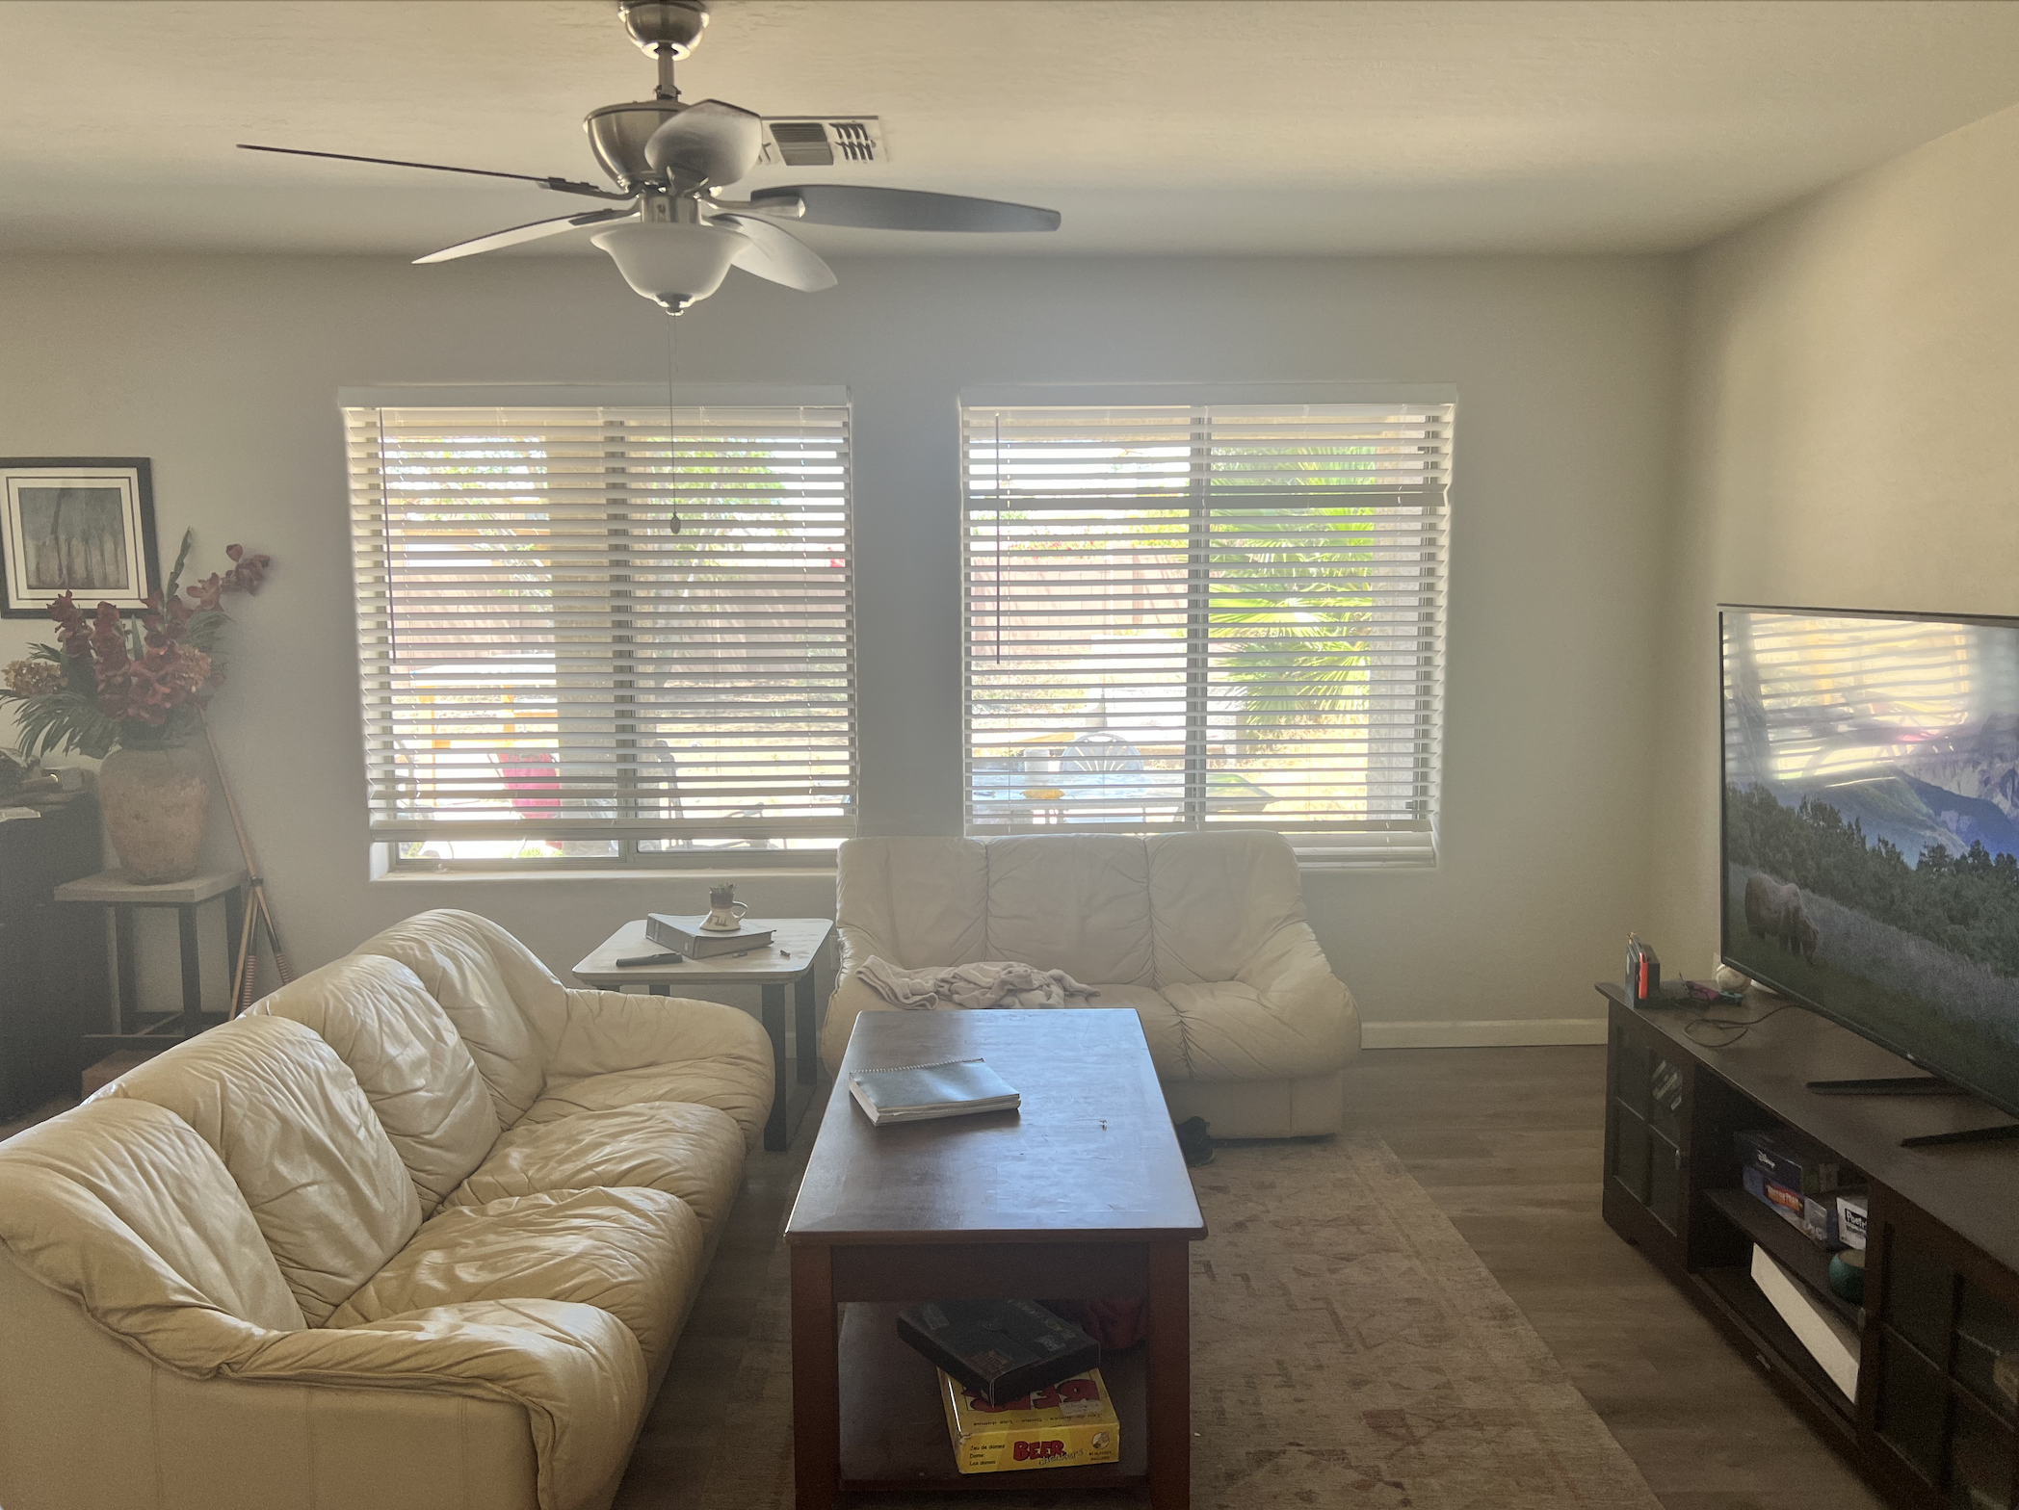

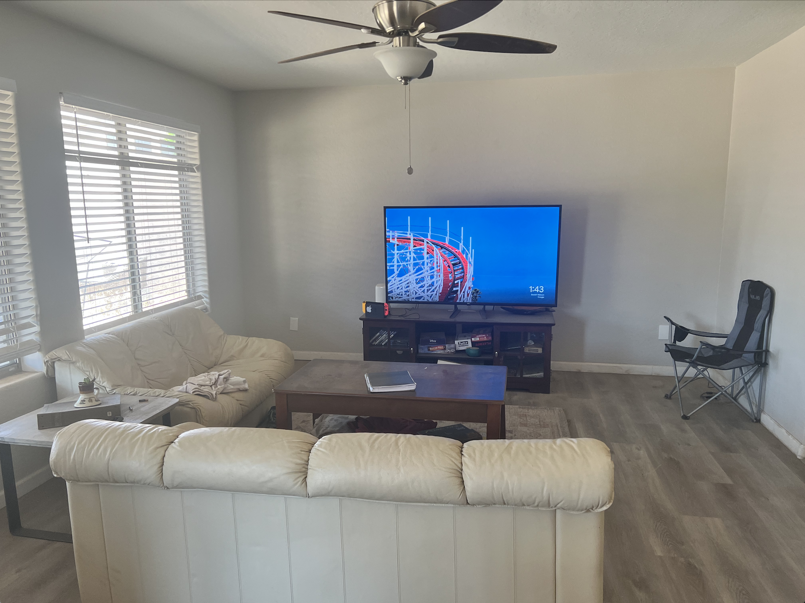

Backyard:

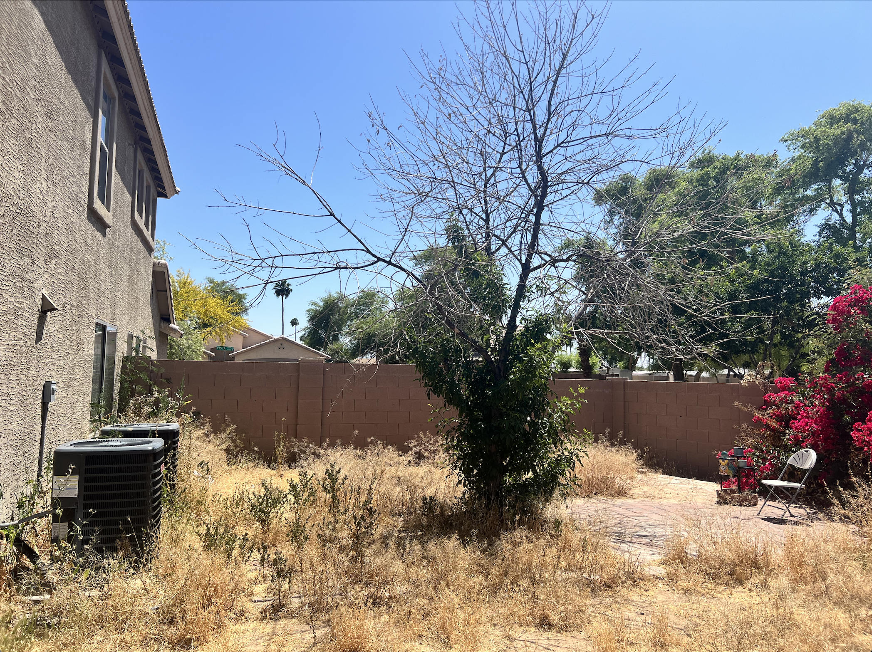

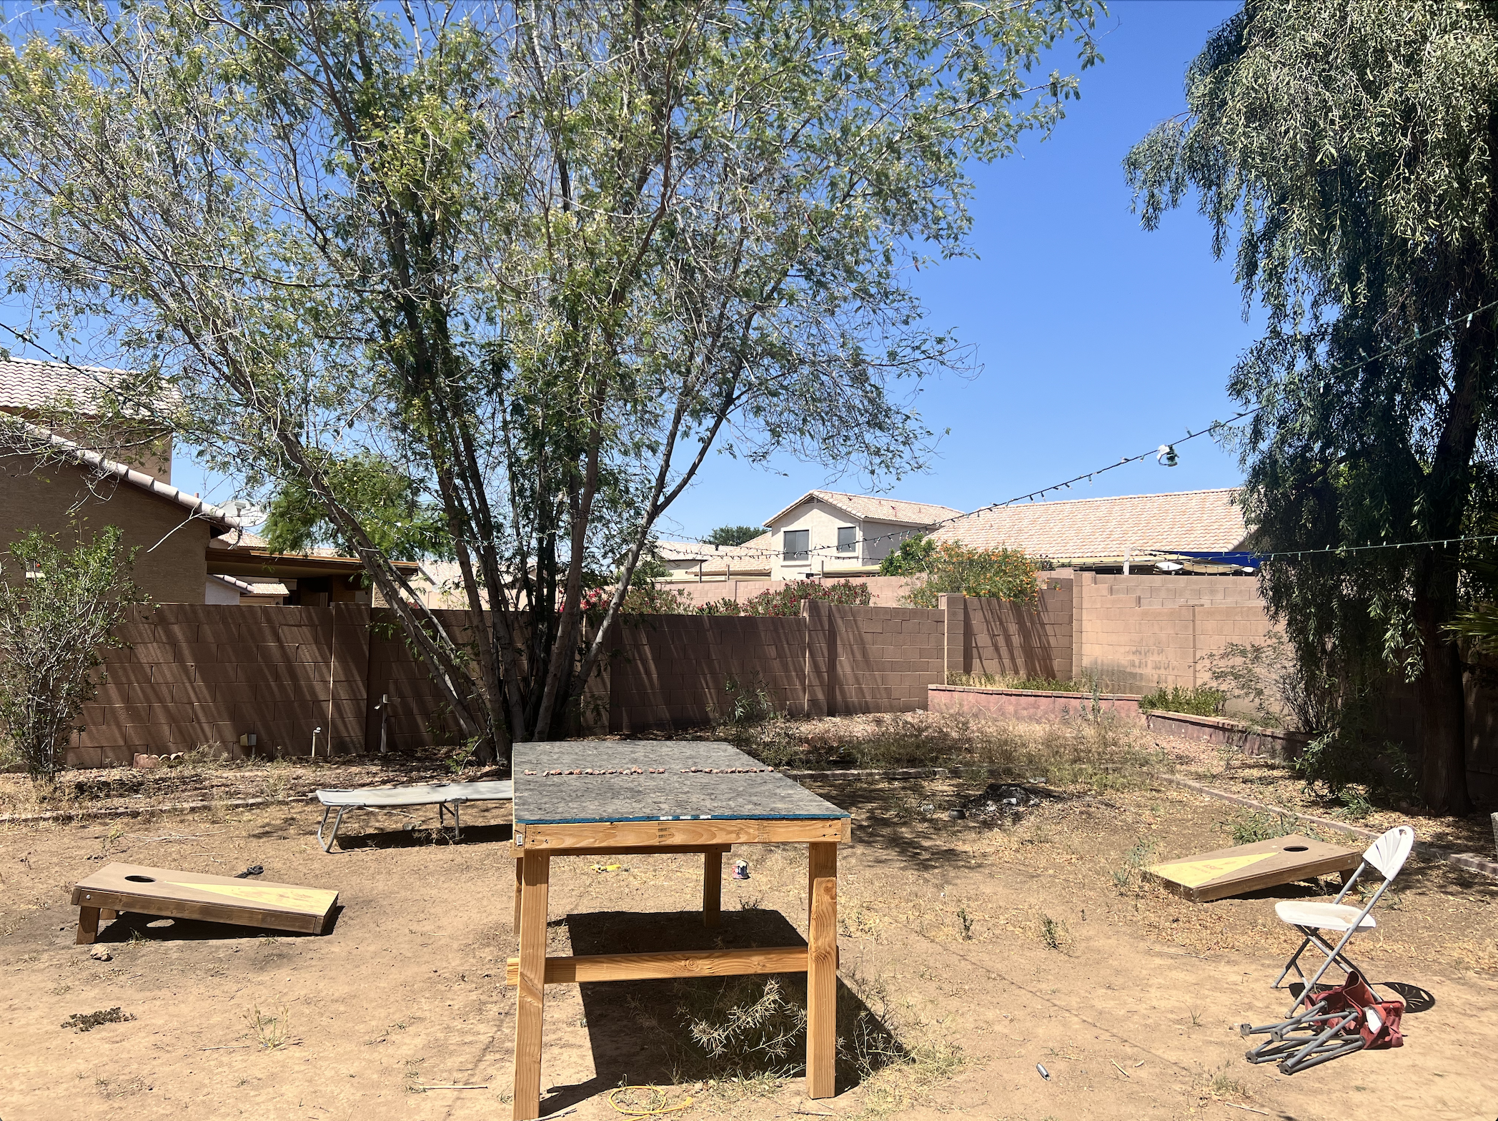

Neighborhood:

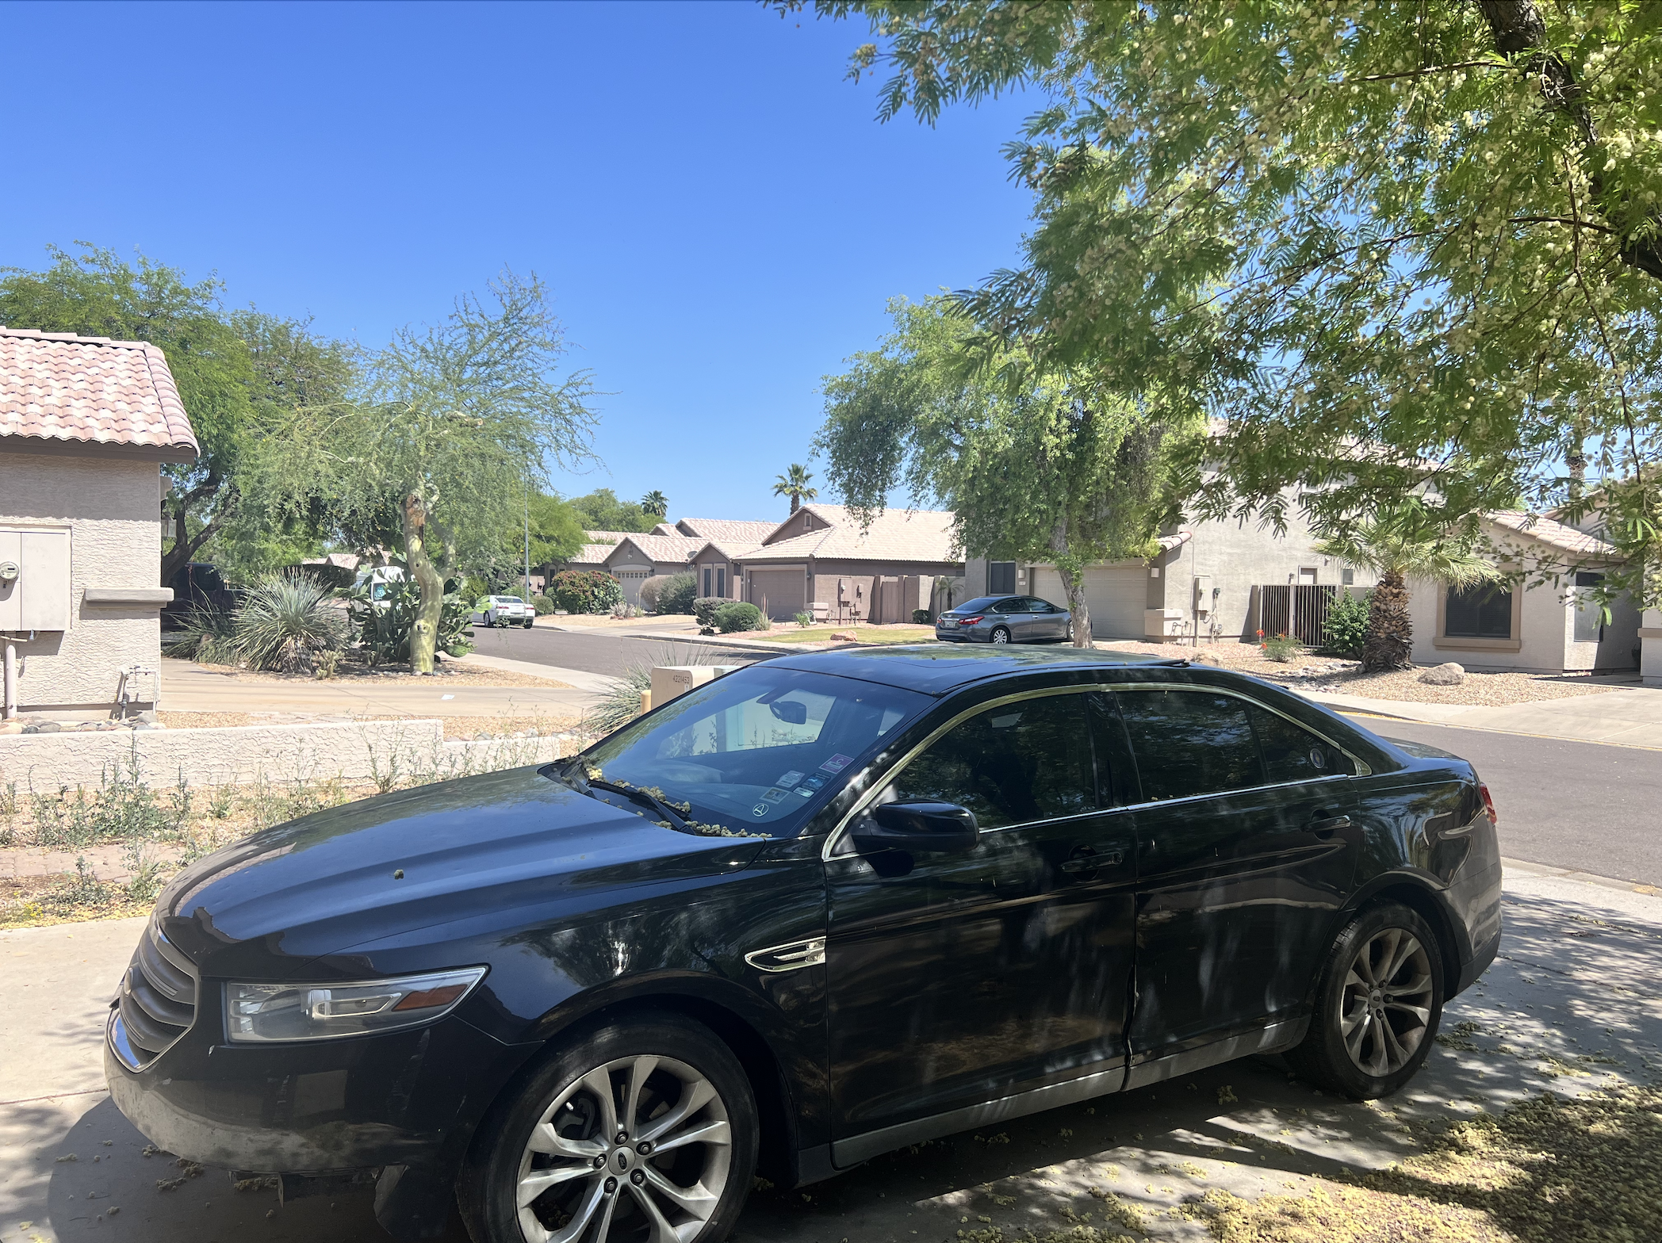

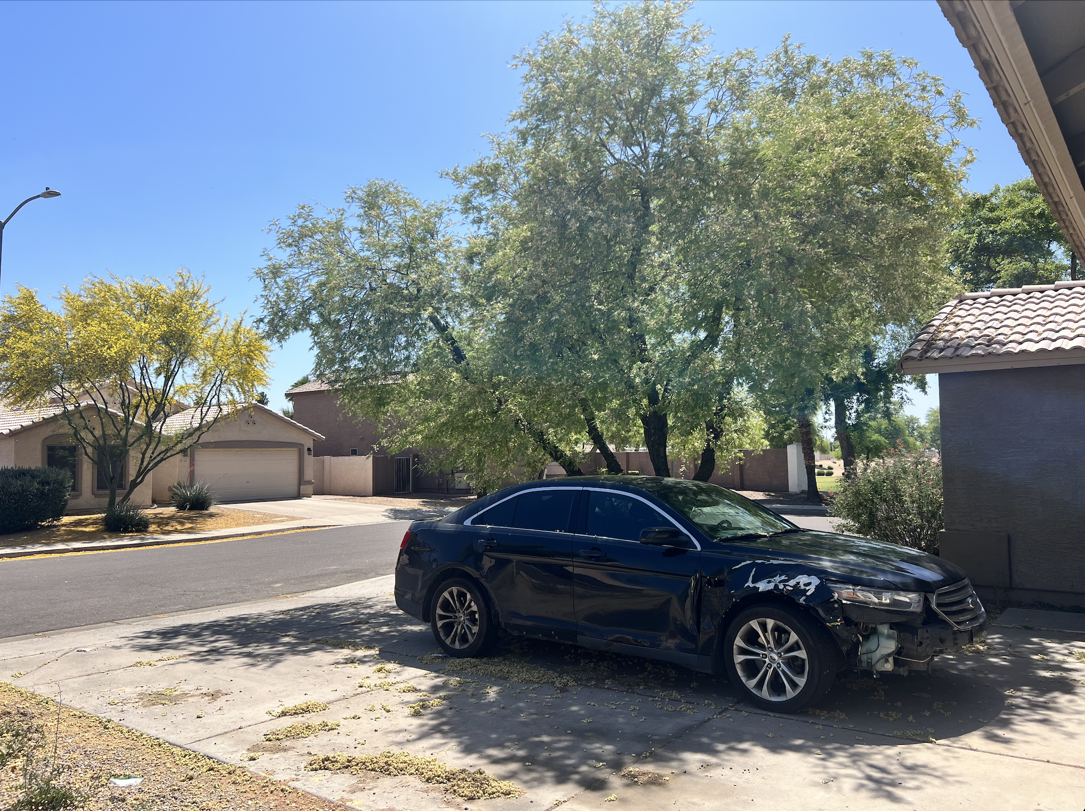

1. Statement of authenticity

5/8/2024

I, Jonathon Moore, took these six pictures with my own camera by myself. They are created by me and only me solely for this class and project. They are not downloaded from the internet or any other source.



Part 2

1. Chosen Picture

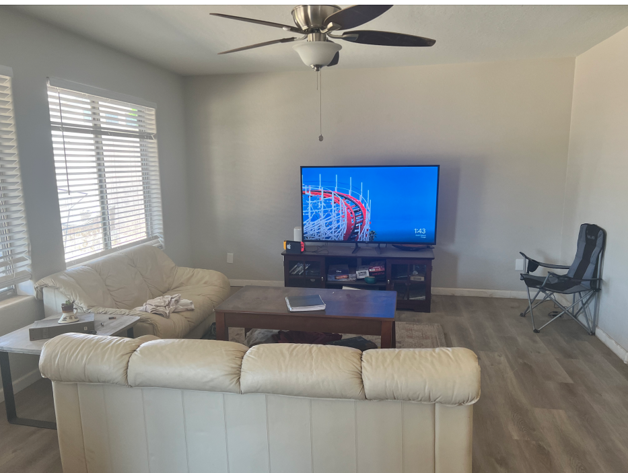

1. Objects in foreground/background and in-between

The objects in the background are going to be:

* TV
* Entertainment Center
* Lawn chair in back right
* Windows/blinds
* Modem and Nintendo Switch

Objects in-between:

* Coffee Table
* Left Couch
* Binder on coffee table
* Ceiling fan

Foreground objects are:

* Front Middle Couch
* Left Table
* Binder on left table

1. Key characteristics of the scene

For this scene it is a modern tidy living room, the room is well lit with natural light coming in through the windows and with a brighter tone for the walls and couches looks very lively. While also being minimalistic the space seems open and airy in ambiance, not feeling confining in any way. As it is a living room the main entertainment is the television with the couches facing towards it, with an astray lawn chair on the right side.

1. My approach to rendering each object

Background:

* TV: A vertical rectangular cube for the face that is thin but tall and wide. Then two small sticks coming our of the middle down to the entertainment center with two horizontal pieces to act as the bottom of the legs.
* Entertainment Center: For this object we will have a thin rectangular prism as the top and back, bottom and middle shelf, while for the side cabinets having two larger cubes to contain those areas.
* Lawn chair in back right: This object will be simplified as of now to have a back made of a thin rectangular prism, as well as one for the seat and the arms which will be connected similarly to the base. Then for the legs will be four long square vertical prisms.
* Windows/blinds: The windows will just be a rectangular prism cutting out of the wall area.
* Modem and Nintendo Switch: The modem will be a tall cylinder and the Nintendo switch will be a rectangular prism with two small cylinders on each end to represent the controllers.

Objects in-between:

* Coffee Table
* Left Couch: The left couch will be made of two large rectangular prisms, one horizontal for the sitting area and one vertical for the backing. Then a cylinder for each arm rest and the neck rest on top of the backing.
* Binder on coffee table: This will just be a rectangular prism with a cylinder for the spirals.
* Ceiling fan: This will be represented with a half circle on the ceiling facing downwards, then a thin cylinder and another half circle dome for the light. Then with thin rectangular prisms at a slight angle to represent the fan blades coming from between the two domes.

Foreground:

* Front Middle Couch: Similar to the left couch it will, be made of two large rectangular prisms, one horizontal for the sitting area and one vertical for the backing. Then a cylinder for each arm rest and the neck rest on top of the backing.
* Left Table: The left table will be made of a thin rectangular prism for the top and the same for legs, however it will have the legs connected at the bottom with another prism.
* Binder on left table: This will be done with a rectangular prism with the left edge being taller than the right to get the angle correct.

1. Rendering difficulty ranking

Ranked from most difficult to least difficult.

* 1. Ceiling fan
  2. Front Middle Couch
  3. Left Couch
  4. Entertainment Center
  5. Coffee Table
  6. TV
  7. Lawn chair in back right
  8. Left table
  9. Modem and Nintendo Switch
  10. Binder on left table
  11. Binder on coffee table
  12. Windows/blinds

1. Drawn geometrical picture

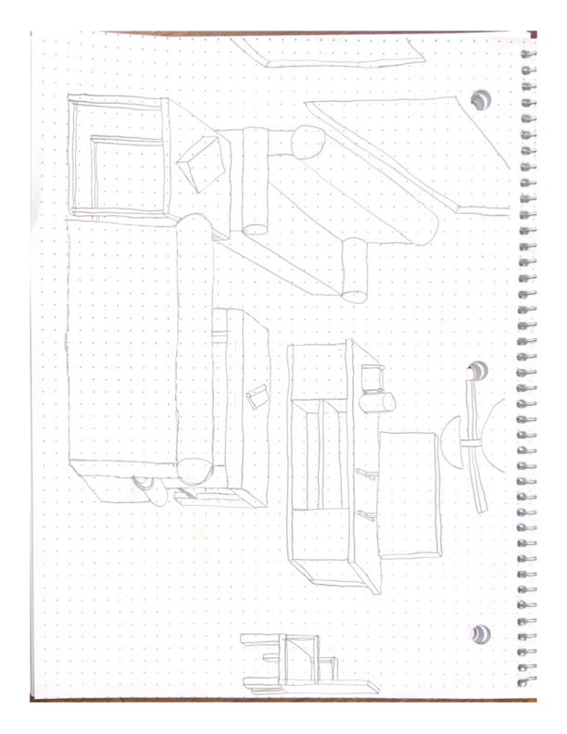

1. Side-by-side comparison

Part 3:

1. Explanation of each object

For the implementation of the objects they are made with three main functions that I created, with variations among them for certain rotations. These are drawRectangularPrism(), drawCylinder(), and drawHemisphere(). The drawRectangularPrism() takes in an x, y, and z position which will be the center of the prism, from there I draw out the six different faces using glVertex3f moving out halfway from the origin position. Similarly, drawCylinder() takes an x, y, and z position, however from here we draw a circle on the top using slices with a triangle fan, then one on the bottom with the same method, then for the cylinders side we use a quad strip and, using the radius and height draw out the sides. For the drawHemisphere() function we take an x, y, and z position, from there we iterate over a sphere using triangle strips, however we only iterate over half of the sphere, making sure to cover the top half with a circle. For the implementation of the objects I wanted to build them out first and get the size, dimensions, and shape correct first, before implementing them into the scene. To do this I went object by object creating them and using variables for its x, y and x position, from these variables I made all of the primitive shapes for the object correlate to eachother so I could move the object as a whole simply by adjusting the three variables, saving a lot of time in creating the scene once the objects were built.

Objects:

* TV: For the tv I used a prism for the screen that was pretty thin, then another for each of the legs.
* Entertainment Center: For this object I used a thin prism for the top and bottom, then I did the same for a back plate to cover the back. From here I used a larger more cube like prism to represent the cupboards on the left and right, then an even thinner prism for the middle rack.
* Coffee Table: The coffee table used a thick and wide prism for the top, then four legs were drawn vertically below it and connected to the top plate, then the bottom plate was added a little bit above the bottom legs but much thinner than the top plate.
* End Table: The end table was made with a thin prism for the top, then four thin but long legs with two more bottom prisms connecting the bottom of the legs to create the looping effect.
* Chair: The chair was made with a prism on the right side for the backing of the chair, then the seating was created with a prism that was not as wide. From there four legs were created on each corner with a prism that lead to the ground.
* Left Couch: This object was made with a large and long prism for the sitting, then a thinner but taller prism for the back plate on the left side. From here a cylinder was drawn at the top of the back plate that was a little bit wider than the back plate, finally two horizontal cylinders were drawn ton each end to represent the arm rest cushions.
* Front Couch: Same as the left couch but wider.
* Ceiling Fan: This was drawn with a hemisphere at the top, then with a prism going down out the bottom of it. From there another smaller hemisphere was connected to the bottom of the prism. Finally two fan blades were added as prisms on either side of the middle connecting prism.
* Binders: The binders were created with a thin prism that was a little bit longer than it is wide and then a cylinder attached to the left side to act as the spine and binder rings.
* Switch: This object was drawn with an upright thin prism with two vertical cylinders on either side of it to act as the connected controllers.
* Modem: This was simply drawn with a cylinder that was a little bit longer and wider.

One thing to note is that for the cylinder there are multiple functions, drawing vertically, straight, or horizontal. These were achieved by applying a rotation on the original “Straight” cylinder which went directly forward from the direct view of the user. The horizontal was rotated 90 degrees in the y direction, and the vertical was rotated 90 degrees in the x direction. The scene, when ran, will open to the closest that I could find to the original rotation of the scene, however can be rotated freely to any direction using WASD controls respectively for a more open and better look at what the scene contains.

1. Screenshots

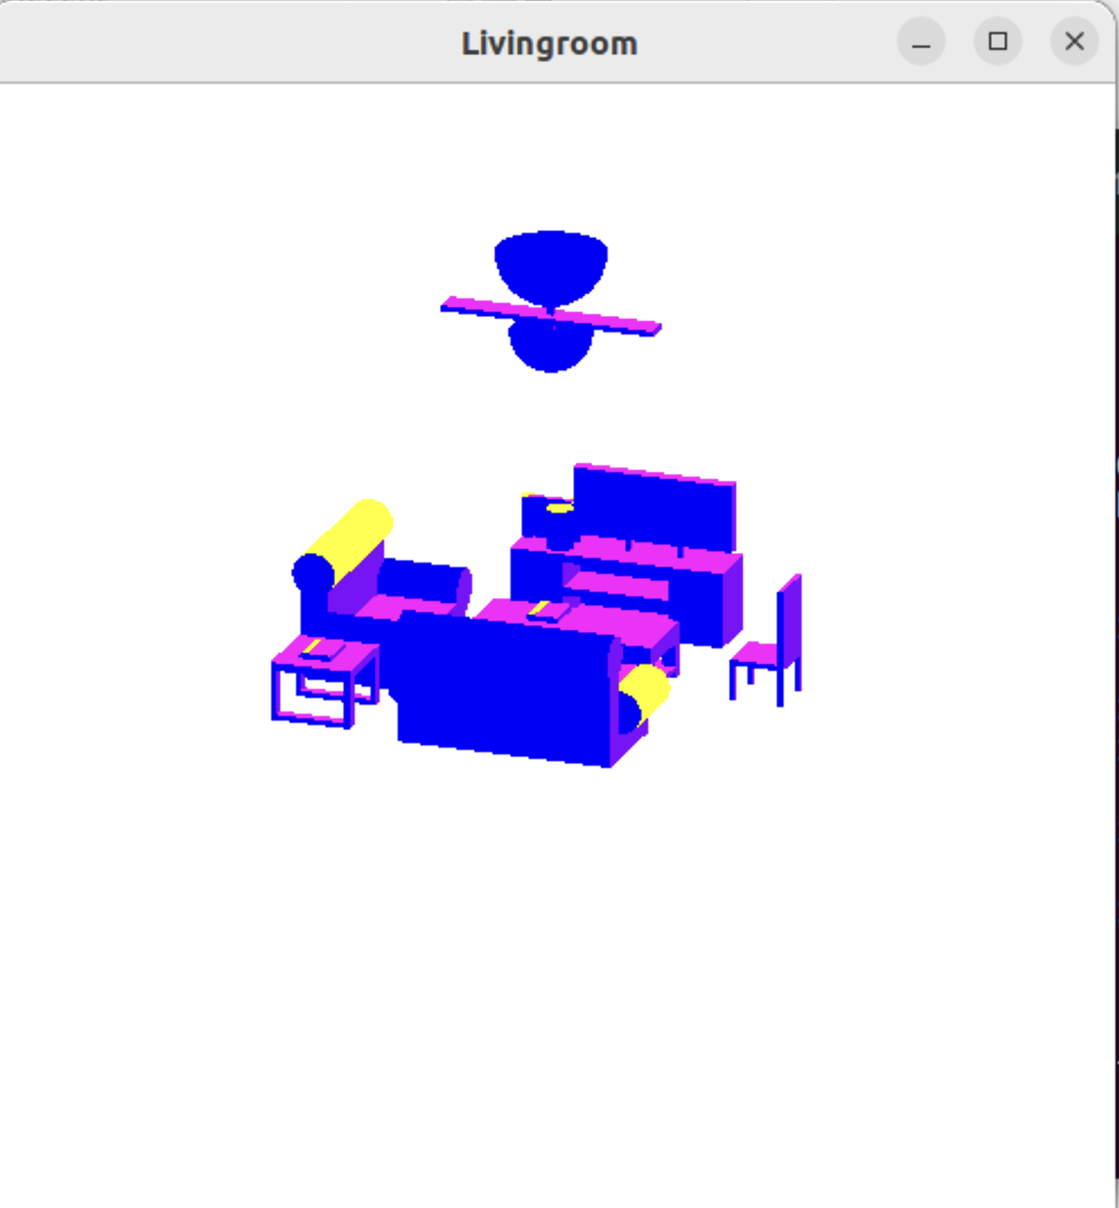Starting view:

Reversed side view:

